**DChain NFT Marketplace**

**Tagline**

"Empowering Collectors and Gamers with Unique Digital Assets"

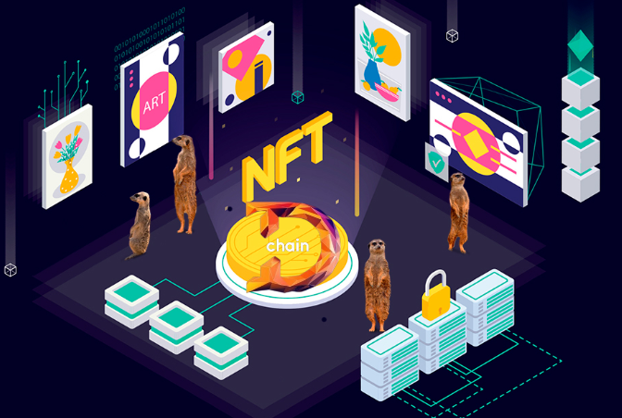

**Overview**

DChain NFT Marketplace is a premier platform dedicated to the buying, selling, and renting of NFTs, specializing in digital collectibles from games and studios. By leveraging DChain's innovative liquidity system and strategic partnerships, we provide a unique ecosystem that fosters a vibrant community of collectors and gamers.

**Features**

**1. Buying and Selling NFTs**

* **Extensive Marketplace**: Discover a diverse range of digital collectibles, including in-game items, artwork, and exclusive assets from partnered studios.
* **Seamless Transactions**: Enjoy a user-friendly interface that simplifies the buying and selling process, ensuring a smooth experience for all users.
* **Secure Payments**: All transactions are secured through blockchain technology, providing transparency and trust.

**2. Renting NFTs**

* **Flexible Rental Options**: Users can rent their NFTs to others for a specified duration, allowing for temporary access to exclusive digital assets.
* **Smart Contract Automation**: Rental agreements are managed through smart contracts, ensuring that terms are met and providing security for both parties.

**3. Community Engagement**

* **Interactive Forums**: Join discussions with fellow collectors and gamers, share insights, and learn from community experiences.
* **Exclusive Events**: Participate in special events and drops that offer limited-edition NFTs, enhancing your collection and engagement with creators.

**4. Unique Liquidity System**

* **Efficient Trading**: Our liquidity system ensures that users can quickly buy or sell their NFTs, maximizing trading opportunities.
* **Partnerships for Exclusive Access**: Collaborations with game developers and artists provide users with unique assets that cannot be found elsewhere.

**5. Creator Support**

* **Empowering Artists**: Tools for creators to mint, manage, and showcase their NFTs, promoting a thriving ecosystem for digital art.
* **Royalties on Resales**: Artists earn a percentage from secondary sales, ensuring they benefit from the ongoing value of their creations.

**6. Advanced Search and Filtering**

* **Easy Navigation**: Utilize advanced search filters to quickly find specific NFTs based on categories, price, rarity, and more.
* **Detailed Listings**: Each NFT listing includes comprehensive details, including ownership history and verification status, enhancing buyer confidence.

**7. Bidding System**

* **Dynamic Pricing**: Sellers can set up auctions for their NFTs, allowing buyers to place bids and potentially acquire assets at competitive prices.
* **Expiration Features**: Bidding options include expiration dates, creating urgency and excitement in the purchasing process.

**8. Wallet Integration**

* **Secure Storage**: Users can securely store their NFTs and cryptocurrencies within the marketplace, ensuring safety from external threats.
* **Easy Access**: Integrated wallets allow for quick transactions and easy management of digital assets.

**Getting Started**

**1. Create an Account**

* Sign up with your email or connect your crypto wallet to begin exploring our marketplace.

**2. Explore and Discover**

* Browse through our extensive collection of NFTs and find unique digital assets that resonate with your interests.

**3. Engage in Transactions**

* Buy, sell, or rent NFTs with confidence, utilizing our secure payment system and smart contracts.

**4. Join the Community**

* Participate in forums and events to connect with other users and stay informed about the latest trends in the NFT space.

**Conclusion**

DChain NFT Marketplace is designed to bring together collectors, gamers, and creators in a dynamic and secure environment. Whether you are looking to buy, sell, or rent NFTs, our platform offers an unparalleled experience that enhances the value of digital collectibles. Join us today and be part of the future of digital asset ownership!